Infused with lemon freshness and formulated to be gentle on skin. Get professional cleaning results without the harsh chemicals.
Price: 35.99
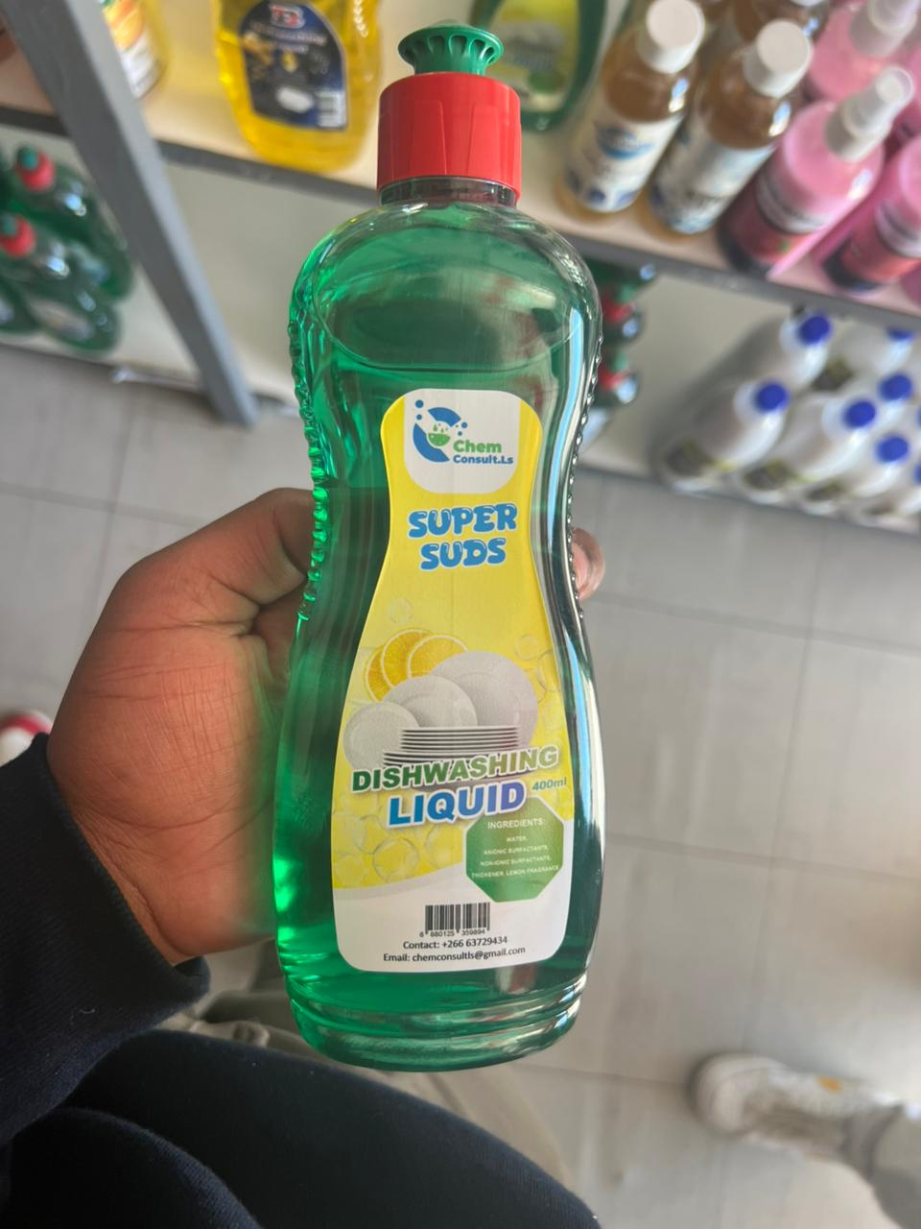

Fabric Softener- Ikutloe u natefetsoe ke monko o monate o tsoarellang nako e telele, le liaparo tse bonolo.
Theko: M60.00
Sebaka: MILCO, Sefika Complex, Maseru
Linomoro: +26658921648



POKOMA CORN MEAL (phoofo ea poone), e thusa ka ts’ilo ea lijo e hantle
Theko: M35.00 (2kg)
Sebaka: MILCO, Sefika Complex, Maseru
Linomoro: +26658921648

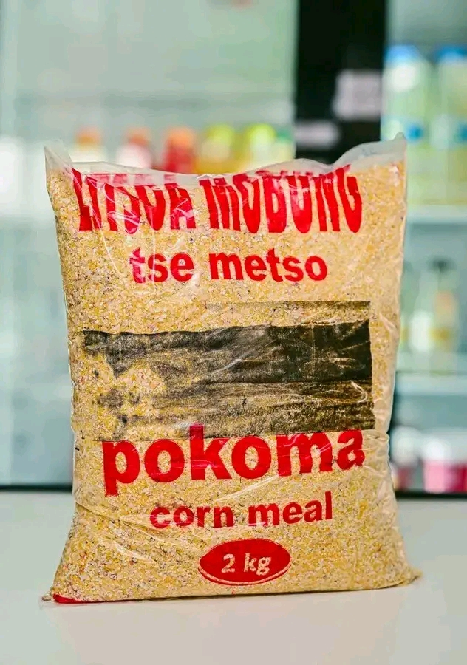

Nama ea poli le nku ea fumaneha
Theko: M145.00 per kg
Sebaka: MILCO, Sefika Complex, Maseru
Nomoro ea Mohala: 58921648

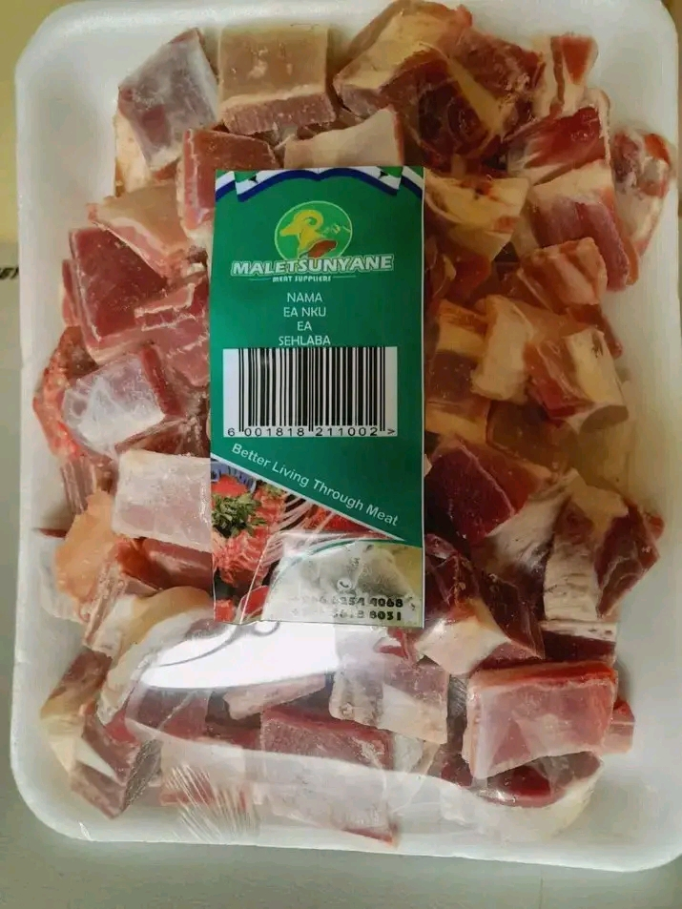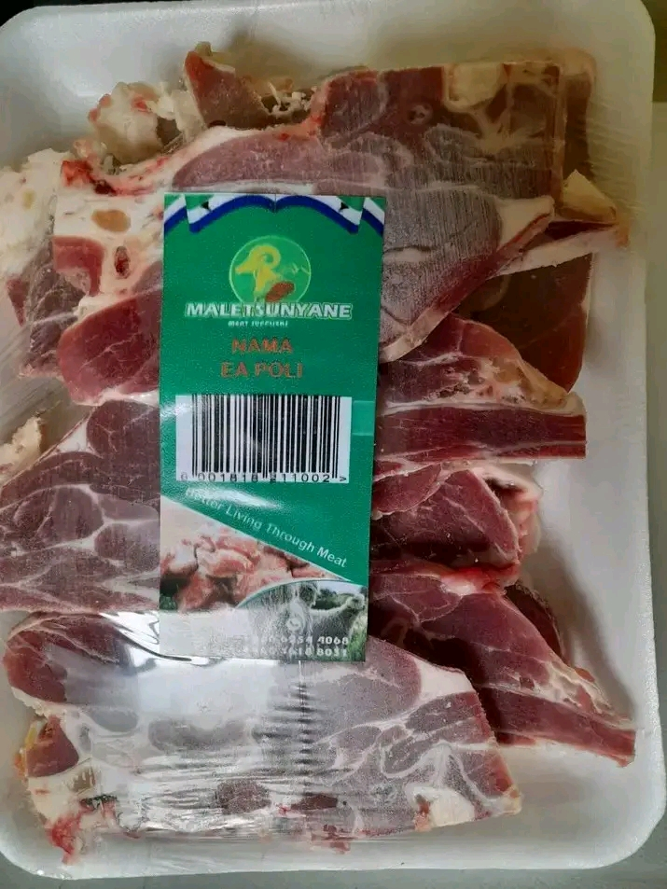

Spices with benefits. Bird’s Eye Chilli is not just about the burn. It is packed with Vitamin C to boost your immunity and capsaicin to fire up your metabolism.
Theko: M39.99
Sebaka: MILCO, Sefika Complex, Maseru
Linomoro: +26658921648
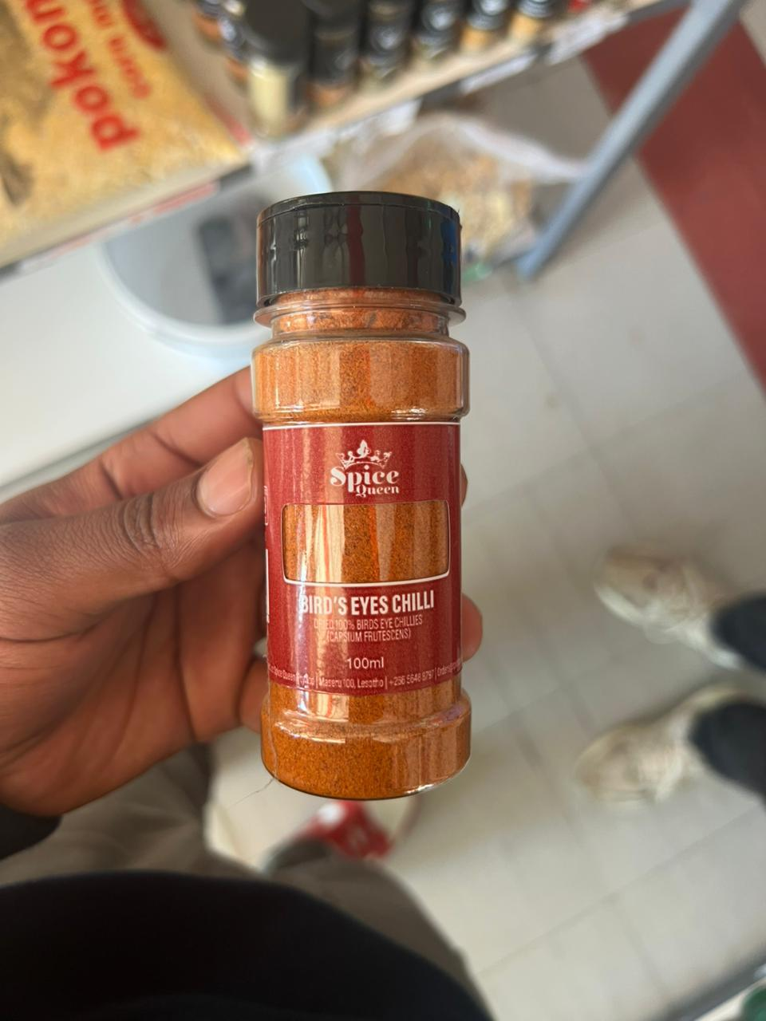

Power through grease with this high-foaming dishwashing liquid tough on stains, gentle on your hands.
Enjoy a fresh lemon scent while its pH-balanced formula delivers maximum cleaning power.
Theko: M20.00
Sebaka: MILCO, Sefika Complex, Maseru
Linomoro: +26658921648
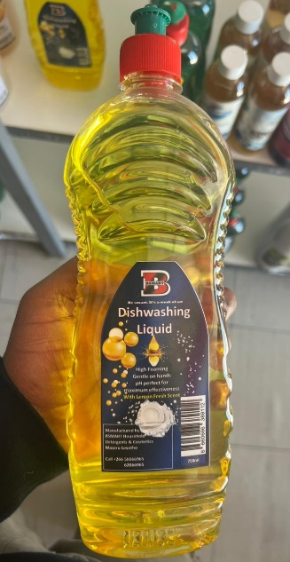

Bay leaves enrich your meals naturally, boost digestion, add antioxidants, and unlock deep flavor in every bite.
Theko: M10.00
Sebaka: MILCO, Sefika Complex, Maseru
Linomoro: +26658921648
